Data Structure and Algorithm

Laboratory Activity No. 2

Algorithm Analysis and Flowchart

|  |  |
| --- | --- |
| *Submitted by:* | *Instructor:* |
| Eulin, Ryan Bertrand B. | Engr. Maria Rizette H. Sayo |

08/02/2025

# Objectives

Introduction

Data structure is a systematic way of organizing and accessing data, and an algorithm is a step-by-step procedure for performing some task in a finite amount of time. These concepts are central to computing, but to be able to classify some data structures and algorithms as “good,” we must have precise ways of analyzing them.

This laboratory activity aims to implement the principles and techniques in:

* Writing a well-structured procedure in programming
* Writing algorithm that best suits to solve computing problems to improve the efficiency of computers
* Convert algorithms into flowcharting symbols

# Methods

* 1. Explain algorithm and flowchart

Algorithm is the collection of steps and the flowchart

is the diagram for those steps

-x, x<0

x, x ≥ 0

* 1. Write algorithm to find the result of equation: f (x) = and draw its flowchart

Click here for the Algo and Flowchart:

<https://drive.google.com/file/d/1myKM_N4yqbx_-r5Qo_9WVoDrhyoA_tXE/view?usp=sharing>

* 1. Write a short recursive Python function that finds the minimum and maximum values in a sequence without using any loops

Click here for the Source Code:

<https://colab.research.google.com/drive/1FDpRamKNKr6dduKBRXNI-va78eNwZrU1?usp=sharing>

# Results

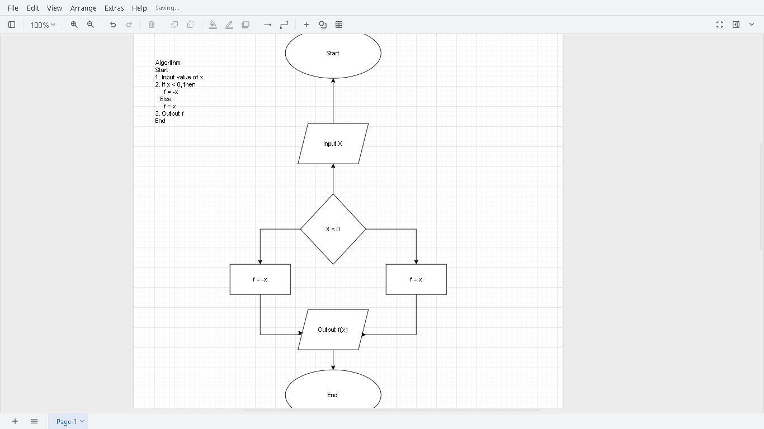

Here is the algo and the flowchart, where I put the start in an oval next to a input and decision in a diamond and right side is the positive x and the left side is the negative x.

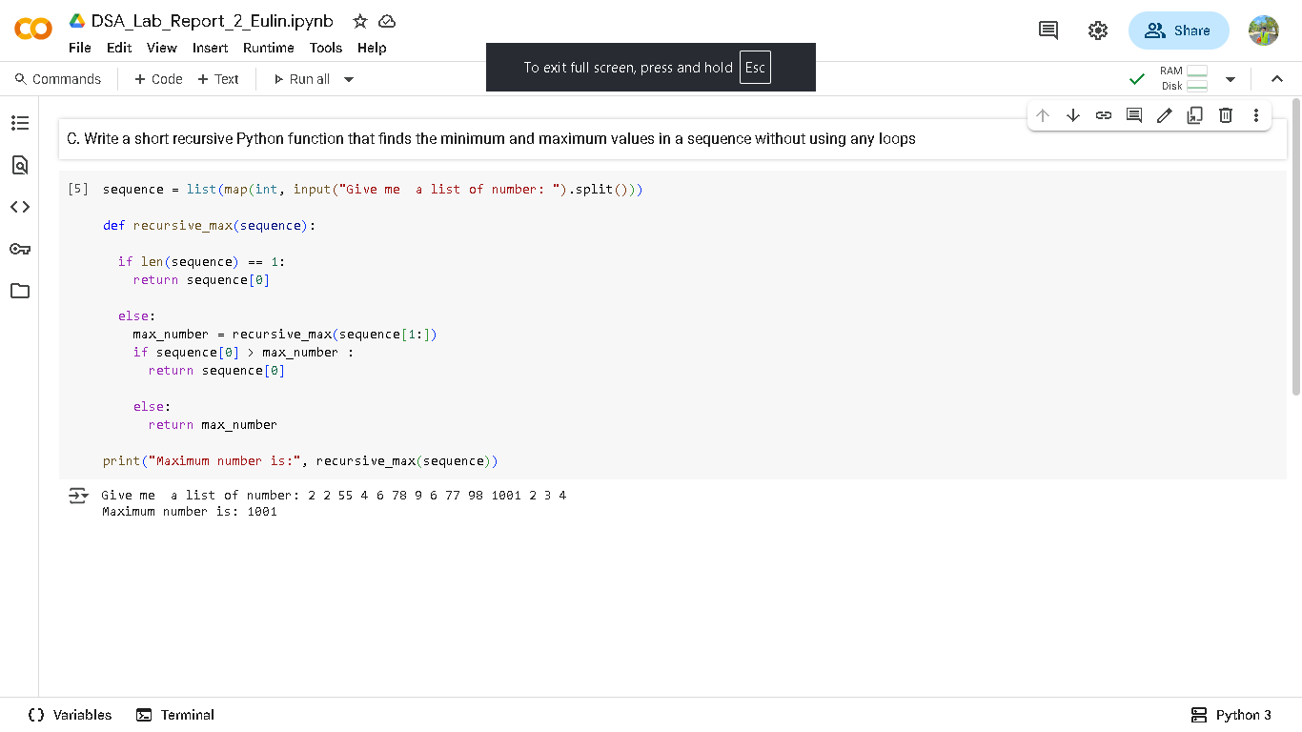

Here is the last part C. the class is task to create a source code for the max and min without using loops.

# Conclusion

In conclusion I learned to create a algo again and flowchart and know how list function works and map function in this type of problem.